**Dolling App**

**Team ID: B21-CAP0114**

**Selected theme: Economy Resilience  
Mentor: Muhammad Fikri Kawakibi Huda (CM25)** (mentoring done on [28-05-2021])

**Member :**  1. Bintang Fathur Rahman (A0060605)

2. Muhammad Hisyam Zayd (A0060600)

3. Yohana Polin Simatupang (C1141458)

4. Gustavo Thiodorus (C0060598)

5. Rian Nugroho (M0060602)

6. Tiara Yania Ifani Lakita (M2082041)

#### **Backgrounder:**

The high price of land and property makes it difficult for small entrepreneurs to start their business, eventually small entrepreneurs prefer to trade using carts or private vehicles to become *pedagang keliling*. According to the journal “Assessing Mobile Food Vendors (a.k.a. Street Food Vendors) - Methods, Challenges, and Lessons Learned for Future Food-environment Research” by S.C. Lucan, *pedagang keliling*, is an important food source especially in minority and low-income communities. Then according to some survey results from the research in the article "Tugas Akhir Mata Kuliah Perancangan Pengalaman Pengguna - Aplikasi E-Food Khusus Pedagang Keliling Dolling (Dodol Keliling)" as many as 82.6% of respondents complained that it was difficult to predict the arrival of *pedagang keliling* and 73.9% of respondents considered buying from *pedagang keliling* is more practical than buying from regular vendor. Thus we want to solve this problem by using an application that can make it easier for users to order food from *pedagang keliling*.

In Indonesia, there are 18.9 million businesses that fall into the category of street vendors and mobile merchants (Central Statistics Agency, 2016). As a result of the mobility of *pedagang keliling* who frequently move places, they also have difficulty getting customers and vice versa, often customers also find it difficult to find the *pedagang keliling* they want. In addition, the products that are sold by *pedagang keliling* are often products that are unknown to customers. Therefore, a platform is needed to notify the location of the *pedagang keliling* along with the route that the *pedagang keliling* takes, as well as to provide information to customers about the product sold by the *pedagang keliling*.

* Machine Learning:

1. Create vendor recommendation using scikit-learn’s NearestNeighbors
2. Building CNN model using TensorFlow. For 50 epochs, model have 86% train and 42% validation accuracy using food101 datasets (only 10 classes were used during training).

* Android:

1. Creating buyer app and seller app using Android Studio
2. Using Firebase kit including: Firebase Firestore for NoSQL database, Firebase Auth for authentication using email and phone number, and Firebase Storage for storing image files
3. Using jetpack libraries and architecture component guideline while developing apps (viewmodel, livedata, and separation concern concept)

* Cloud:

1. Using service Firestore for the database on the Dolling application.
2. Deploying ML Model in AI Platform and making classification (Version) to get prediction.
3. Build API from Recommendation ML model and image similarity ML model.

#### **Screenshots**

Buying Food App Flow

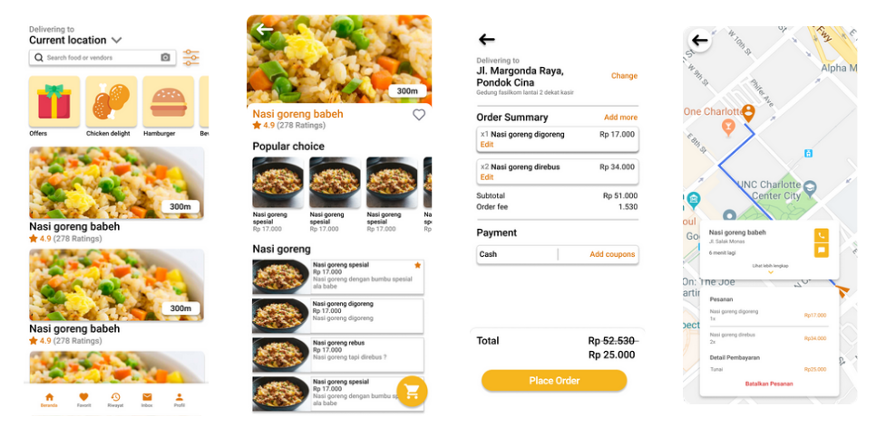

Seller App Flow

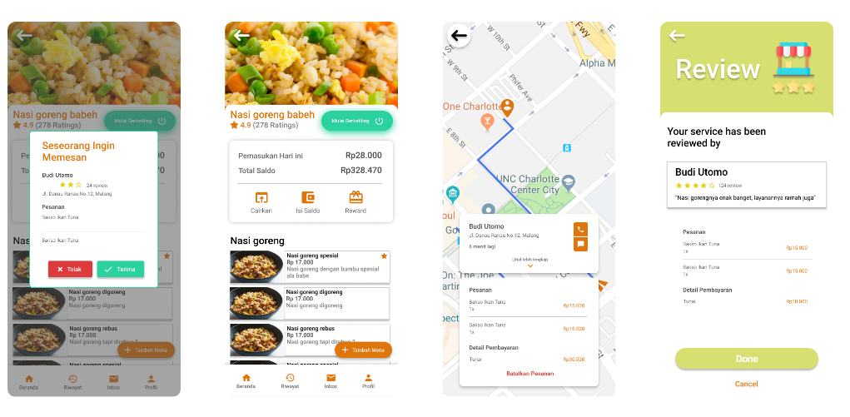

#### **Dataset Link**:

Food Images (Food-101) - Labeled food images in 101 categories from apple pies to waffles:

<https://www.kaggle.com/kmader/food41>

Food Preferences - Food Preferences Survey 2019:

<https://www.kaggle.com/vijayashreer/food-preferences>

Food-11 - This is a dataset containing 16643 food images grouped in 11 major categories:

<https://www.kaggle.com/vermaavi/food11>

#### **Deployed Link:**

<https://drive.google.com/file/d/124Z7sbqiD4hWyGanpKwdqwfBcOeFr--2/view?usp=sharing>

#### **Github Repo Link:**

**Android**

<https://github.com/hisyamzayd/dolling>

**Machine Learning**

Recommendation:

<https://colab.research.google.com/drive/1YtRKBG7CivYOz-BcAneVvFZdhAKqNMKV?usp=sharing>

Image Similarity:

<https://colab.research.google.com/drive/1UgmbRC37AcM9a9pp0gadWmVSSoUNnkPY?usp=sharing#scrollTo=6CAIilW-8BmO>

#### **Academic Paper Link:**

Tugas Akhir Mata Kuliah Perancangan Pengalaman Pengguna - Aplikasi E-Food Khusus Pedagang Keliling Dolling (Dodol Keliling):

<https://www.scribd.com/document/505970990/Tugas-Akhir-PUX>

DeepFace: Closing the Gap to Human-Level Performance in Face Verification:

<https://www.cs.toronto.edu/~ranzato/publications/taigman_cvpr14.pdf>

Indonesian Food Items Labeling for Tourism Information Using Convolution Neural Network:

<https://ieeexplore.ieee.org/document/8304158?anchor=keywords>

CNN-based Features for Retrieval and Classification of Food Images:

<https://www.sciencedirect.com/science/article/abs/pii/S1077314218302467>

An optimized convolutional neural network with bottleneck and spatial pyramid pooling layers for classification of foods:

<https://www.sciencedirect.com/science/article/abs/pii/S0167865517304452>

Assessing mobile food vendors (a.k.a. Street food vendors) - methods, challenges, and lessons learned for future food-environment research:

<https://www.researchgate.net/publication/253333510_Assessing_mobile_food_vendors_aka_street_food_vendors-methods_challenges_and_lessons_learned_for_future_food-environment_research>

#### **10-Min Video Presentation Link:**

<https://youtu.be/Gp0YwjEztqM>

#### **Slide Presentation Link:**

Team Presentation:

[DOLLING APP (2).pptx](https://drive.google.com/file/d/1uqAckfeKv2FMv7OSu4fr4gIlVRK-ZUqe/view?usp=sharing)

Goto Market Presentation:

[Go-to-Market Proposal](https://docs.google.com/presentation/d/1DoqbNM8pR_vdbjM8U45R7s4C80_u8wXYy1hG8WCi9fA/edit?usp=sharing)